Business Plan

K2
ENGINEERING & CONSTRUCTION PVT LTD.
(Housing Complex)

K2 Engineering & Construction PVT Ltd
Address: Sector 162,Plot No-10 Near Amity University/Jaypee Green House, Noida - 201301, India
Tel: + 91-7979028591
Email:customercare @k2engineering.co.in
Web: www.k2engineering.co.in



Corporate Presentation

K2
ENGINEERING & CONSTRUCTION PVTLTD.
(Housing Complex),K2 Stand for Kashinath –Lord Shiva

Under the Guidance of Mentor & Sr. Faculty Guide:
Prof. Ajith Kumar J.(B.Tech & M.Tech-IIT Kanpur, Phd-IIT Madras)
Department of Operation Management
Submitted By:
Kaushal Kishore
NA – 17017
Post Graduate Program- of Entrepreneurship Management, 2017-18
XLRI, Jamshedpur
Values of our company - strong, kind, engaging & well directed.
Strong - We will be deliver excellent products and services that satisfy our clients thus will be able to reward our stake holders.
. Kind – We will contribute to the local & global communities in terms of environmental conservation, ethical behavior, and social contribution
.
Engaging - Employees find their life & work fulfilling interesting' company
Well directed- company is loaded with direction & magnitude and purpose

Certificate
This is to certify that this project report titled “K2 ENGINEERING AND CONSTRUCTION PVT LTD” submitted to XLRI, Jamshedpur in partial fulfillment for the requirements of Post Graduate Program for Entrepreneurship Management is an original and independent work carried out by Kaushal Kishore (NA17017) under my mentorship and guidance

Prof. Ajith Kumar J. Signature
Department: Production, Operation and Decision Sciences Dated:2 1/01/2018
XLRI - Xavier School of Management, (B.Tech & M.Tech-IIT Kanpur, Phd Chennai) Place: Jamshedpur
JAMSHEDPUR 831001,
INDIA

Acknowledgement
At the completion of my project, I would like to express my sincere gratitude to all the people without whose support this project would not be competed.
At the onset, I would like to thank my faculty & my institute “XLRI, Jamshedpur” for giving me the opportunity to undertake this research project.
I would also like to acknowledge the constant help and encouragement of my project guide Prof. Ajith Kumar J., who has given his valuable time, suggestion and guidance along with uninterrupted support.
I would also like to thank those who directly or indirectly helped me for the preparation and completion of this project.

Kaushal Kishore Singh Signature
NA – 17017 Dated:21 /01/2018
Department: PGP - CEM ( Student) ,Batch 2017-18 Place: Jamshedpur
XLRI - Xavier School of Management, jamshedpur

INDEX
1. SUMMARY
2. INTRODUCTION
3. INDUSTRY ANALYSIS
4. COMPETITORS
5. MANAGEMENT
6. BUSINESS CONCEPT
7. MARKETING PLAN
8. FINANCIAL PLAN
9. ANALYSIS SWOT
10. FUTURE PROSPECTS
11. FAQ’S

Company Background:
K2 Engineering & Construction Pvt Ltd has a combination of experienced professionals along with skilled workforce who are adept at executing construction and have expertise with the local regulations, procedures and client requirements in their respective regions (India & Gulf). Most of the project personnel have rich experience of working with regional and international companies, who are readily available as a part of the in-house task force for deployment.
CORE PURPOSE: To facilitate the people with eco-friendly &affordable construction solution for generations to come.
CORE VALUE:
1. Aptitude, Vector, Sustainability, Process oriented ethics.
VISION STATEMENT: We envision a world where all people – even in the most remote areas of the globe – hold the power to create opportunity for themselves and others.
The Industry
- REAL ESTATE BUILDERS – We are planning to develop many world-class residential, commercial and township properties for customers residing in Delhi/NCR and other parts of India. For their high level construction works for housing complex and school institutions.
- Offering-- Civil Structural design (foundation, column, beam, stair, roof slab), structural peer review, bar bending scheduled, preparing bill of quantities for house. In place of old Working Stress Method &Ultimate stress method, company will use Latest Limit State Method, like Vintech consultants
- Industry Analysis -
- Number of home civil designers and companies are there in India- 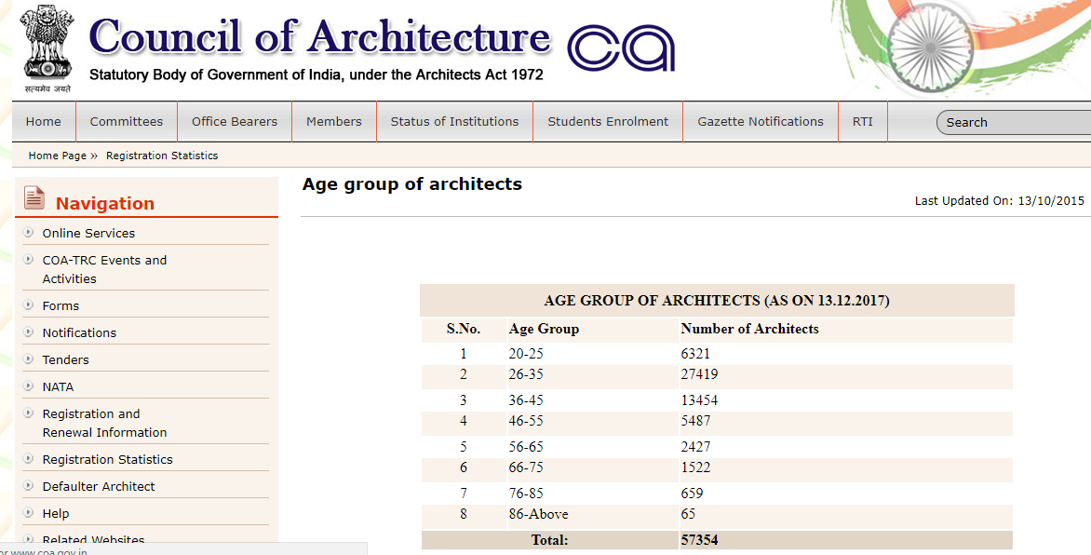
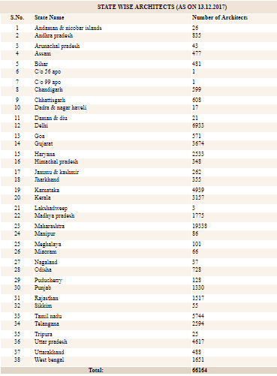
2. Why will the home makers come to us –We are committed to provide high quality services at best market price.We will be providing customized advice & solutions with respect to each project we undertake. We will work in association with our client builder during construction for cost saving solution.We will be providing 24-hours turnaround support on site by our engineering division.

3. Who is your competitor–
(1) Arcop Associates Pvt. Ltd, Sector 128 Sultanpur Noida, www.arcop.co ,recently Jeepee Greens are under construction in Noida in around 1200 acre township.
(2)Behal Joshi & Associates, www.behaljoshi.com
(3) Amrapali Leisure valley Greater Noida is design by Burt Hill (USA) and resident architects Vaibhav Jain & Associates Delhi.
(4)Spertech ltd (www.supertechlimited.com),Supernova Noida Sector-94 is design by Benoy
(5)Architect Hafeez contractor (www.hafeezcontractor.com)

Management Team
CMD - O. P. Pandey, Indian Forest Officer (Retired) with more than 32 yrs of experience as the director general of Environment & forest Govt. of India.
Managing Director – Gopal Krishna (B.Tech. IIT Kanpur, MS – Boston, Software Engg. Microsoft) has more than 12 years of experience in software development.
Chairman –OP Pandey ,IFS(Retired)-Govt of India
Advisor – AKS, General Manager, Govt of India Ltd with 20 years of experience
Director-Kaushal Kishore Singh(B.Tech) having more than 15yrs experience in oil & gas,real estate
Advisor – N SHARMA, Teaching Professional with more than 5 years of experience.
Advisor- BS.
Advisor – A PANDEY, Govt. of India
Advisor –G.Singh, Govt Of India
Excluding the above team, we also have the following people on board:
Group of Engg -Mechnical-2, Electrical-1, Instrumentation & Information-1, Architecture-1
Legal Advisor – 1 Lawyer (LLB)
Financial Advisor - 1 Business Executive ( MBA – Finance)

MARKET SIZE
The Indian real estate market is expected to touch US$ 180 billion by 2020. The housing sector alone contributes 5-6 per cent to the country's Gross Domestic Product (GDP).
In the period FY2008-2020, the market size of this sector is expected to increase at a Compound Annual Growth Rate (CAGR) of 11.2 per cent. Retail, hospitality and commercial real estate are also growing significantly, providing the much-needed infrastructure for India's growing needs.
A total of 2,17,900 new houses in six Indian states were sanctioned by the Ministry of Housing and Urban Affairs, Government of India under the Pradhan Manti Awash Yojana (Urban) (PMAY) to push affordable housing in the urban areas of the country
The private equity investments in real estate increased 26 per cent to a nine-year high of nearly Rs 40,000 corers (US$ 6.01 billion) in 2016.
Sectors such as IT and ITeS, retail, consulting and e-commerce have registered high demand for office space in recent times. The office space absorption in 2016 across the top eight cities amounted to 34 million square feet (msf) with Bangalore recording the highest net absorption during the year. Information Technology and Business Process Management sector led the total leasing table with 52 per cent of total space uptake in 2016. Mumbai is the best city in India for commercial real estate investment, with returns of 12-19 per cent likely in the next five years, followed by Bangalore and Delhi-National Capital Region (NCR).

Investments

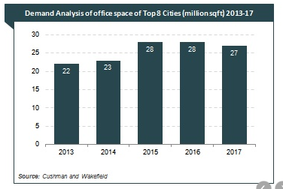Exhibit 1
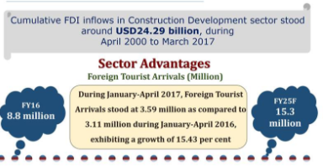Exhibit 2
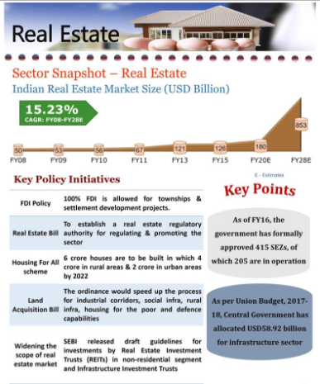Exhibit 3
The Indian real estate sector has witnessed high growth in recent times with the rise in demand for office as well as residential spaces. The real estate sector in India is expected to attract investments worth US$ 7 billion in 2017, which will rise further to US$ 10 billion by 2020. India has been ranked fourth in developing Asia for FDI inflows as per the World Investment Report 2016 by the United Nations Conference for Trade and Development. According to data released by Department of Industrial Policy and Promotion (DIPP), the construction development sector in India has received Foreign Direct Investment (FDI) equity inflows to the tune of US$ 24.29 billion in the period April 2000-March 2017.
Some of the major investments in this sector are as follows:
- International Finance Corporation (IFC) will invest US$ 200 million in Housing Development Finance Corporation Ltd (HDFC) via five-year non-convertible debentures (NCDs) or masala bonds which will be used by HDFC to provide loans for affordable housing projects across India.
- Ascendas - Singbridge Group, a property development company based in Singapore, has purchased six warehouses from Arshiya Limited for a consideration of Rs 534 crore (US$ 83 million), of which Rs 434 crore (US$ 67 million) would be paid on signing the definitive agreement, and the balance over four years on the attainment of certain targets.
- Godrej Properties Ltd has tied up with Taj Palaces Resorts Safaris for developing its mixed-use project called 'The Trees', spread across 9.2 acres, that will include a 150-room Taj Hotel, a luxury residential property called 'Godrej Origins' as well as a high-street retail court.
- Motilal Oswal Real Estate, a real estate-focused investment subsidiary of Motilal Oswal Private Equity Advisors Pvt Ltd, is planning to invest Rs 800 crore (US$ 124 million) in FY 2017-18 in mid-income residential projects as well as commercial office projects.
- Xander, a Private Equity Group, has signed two major property deals, which includes a special economic zone worth Rs 2,290 crore (US$ 354.95 million) in Chennai and a 2 million sq ft mall in Chandigarh for Rs 700 crore (US$ 108.5 million).
- Canada Pension Plan Investment Board (CPPIB), the Canadian pension asset manager, has entered into a non-binding agreement with Island Star Mall Developers (ISML), a subsidiary of Phoenix Mills, to acquire up to 49 per cent in ISML in the next three years.
- Altico Capital, a non-banking finance company (NBFC), has teamed up with American private equity firm KKR & Co LP to invest Rs 435 crore (US$ 65.25 million) in a 66-acre residential township, being developed by SARE Homes in Gurgaon.
- Gurgaon-based property search aggregator Square Yards Consulting Pvt Ltd has raised US$ 12 million from the private equity arm of Reliance Group for strengthening its team and expanding its presence to more than 25 countries.
- Rising Straits Capital plans to raise US$ 100 million to capitalise its real estate-focused non-banking financial company (NBFC), Rising Straits Finance Co. Pvt. Ltd.
- A joint venture between Dutch asset manager APG Asset Management and real estate asset platform Virtuous Retail, has acquired a portfolio of three shopping malls for US$ 300 million, and has committed an additional US$ 150 million as equity capital to expand the portfolio.
- Macquarie Infrastructure and Real Assets (MIRA) and Tata Housing Development Co. Ltd have entered into a 70:30 partnership to invest Rs 1,400 crore (US$ 210 million) and Rs 600 crore (US$ 90 million) respectively in high-end residential property projects, starting with four major cities of Mumbai, NCR, Bengaluru and Pune.
- Qatar Holdings LLC, a subsidiary of Qatar Investment Authority, has committed to invest US$ 250 million in the affordable housing fund of Arthveda Fund Management Pvt Ltd.
- Piramal Realty, the real estate division of Piramal Group, plans to invest Rs 1,800 crore (US$ 270.14 million) in an eight acre project named Piramal Revanta in Mulund, Mumbai.
- Ivanhoe Cambridge, the real estate arm of Canada’s second largest pension fund manager Caisse de dépôt et placement du Québec (CDPQ), plans to enter into a Joint Venture (JV) agreement with Piramal Fund Management to set up a US$ 250 million venture, which will provide equity capital to developers of residential projects in the country.

Government Initiatives
The Government of India along with the governments of the respective states has taken several initiatives to encourage the development in the sector. The Smart City Project, where there is a plan to build 100 smart cities, is a prime opportunity for the real estate companies. Below are some of the other major Government Initiatives:
- The Delhi Government has declared 89 out of 95 villages in Delhi as urban areas which will ease the operationalizing of the land pooling policy, thereby giving a boost to affordable housing in Delhi.
- The Reserve Bank of India (RBI) has proposed to allow banks to invest in real estate investment trusts (REITs) and infrastructure investment trusts (InvITs) which is expected to benefit both real estate and banking sector in diversifying investor base and investment avenues respectively.
- The Ministry of Housing and Urban Poverty Alleviation has sanctioned the construction of 84,460 more affordable houses for urban poor in five states, namely West Bengal, Jharkhand, Punjab, Kerala and Manipur under the Pradhan Mantri Awas Yojana (Urban) scheme with a total investment of Rs 3,073 crore (US$ 460 million
Business Operational Plan & Execution - Civil Engg Design for home.
1. Broad Approach – Make to order
2. Major Process Type - Project, Line Process
3. Major Process - Collection of soil sample for determination of SBC, as per SBC data and other factor of safety like wind load, dead load, live load, earth quake, design will take place.
4. Supporting Process - Preliminary Topographic survey & leveling are done after fixing Permanent Bench Mark.All data are collected in record book for supporting of design process.
5. Primary inputs - SBC data, BE Civil Engg, Surface area (total area, built-up area, no of floor are required)
6. Supporting Inputs - Electricity, stationary, 3D printer & printer-ink, software like STAAD PRO, CADD, NISSA
7. Supplier of primary Inputs- Lab Noida -This has civil engg. department where our soil and other material will be tested in the laboratory.
8. Supplier of secondary supporter inputs - Noida Power Distribution Corporation, Torsteel Research Foundation Bangalore.
9. Location of facility- Noida input- 10 Feet from FNG highway, 60 feet from metro staion Near sector-18 Noida
10. Primary facility / Infrastructure - Total Area=4000 sq feet and Built –up Area=1600 sq feet,15’/ 16’ -4 room in my own house ,1 –waiting room,1-main office,2 are office room at ground floor, remaining area 2600 are used as for parking etc.
11. Supporting facility /infrastructure –Motorcycle-1, Toyota-INNOVA-1, company has a library, which consists of various national & international code books of civil engineering / structural engineering and three famous IES & GATE coaching institute like Made Easy-Delhi, ACE Hyderabad& Made IES –Delhi class note books for designing & analysis of structure.
12. Major Technology / Equipment - STAAD PRO, CADD, Laptop-5, 3D Printer

13. HR-No Person Qualification Duty Salary (per month INR) Salary (per annum INR)
1 Engineer BE. Civil Head (software + site) 6, 12, 000*1= 6, 12, 000
3 Engineer Diploma Supervisor (software + site) 3, 00, 000 *3= 9, 00, 000
1 Driver 10th pass Vehicle driving 1, 32, 000*1 = 1, 32, 000
2 Helper 8thpass One for office + One for site 84, 000*2 = 1, 68, 000

Total Salary to be given: 18 Lacs (aprox).

14. Quantity-No Equipment/Accessories Specifications
1 STAAD Software
1 NISSA Software
1 CADD Software
1 Total Station Angular LC = 1 second & Dist LC = 1mm
1 Theodolite Vernier, LC = 20 second
1 Dumpy Level LC = 0.5mm
1 Tripod Standard
1 Tachyometer Standard
1 Alidade Standard
1 Plane Table Standard
1 Measuring Tape 100mtr, 50mtrs, 10mtrs
1 Ranging Rod HT= 3 & 5mtrs
1 Leveling Rod HT= 3 & 5mtrs
1 Surveying Metric chain 30 meter (Tallies are fixed at 5mtr)
1 Compass LC=15 minutes
1 Marking Paints Orange / Yellow / White / Red / Black
1 Magnetic Locator Detect metal wire below the surface
10 Pegging rod Standard

Total costing for equipments: 7 Lacs (aprox) annually

Exhibits for reference:
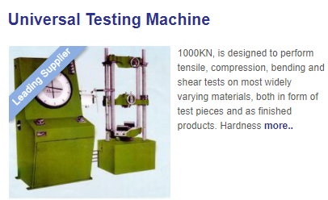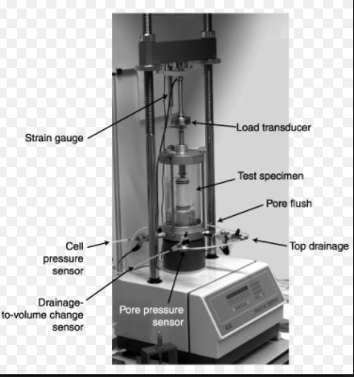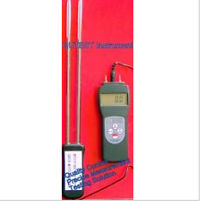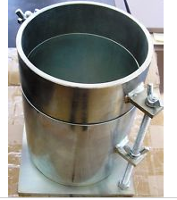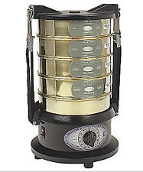
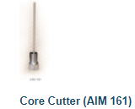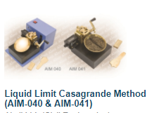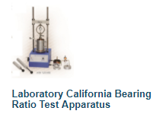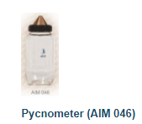
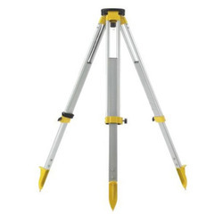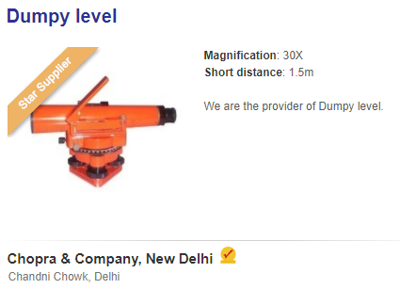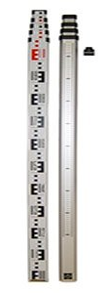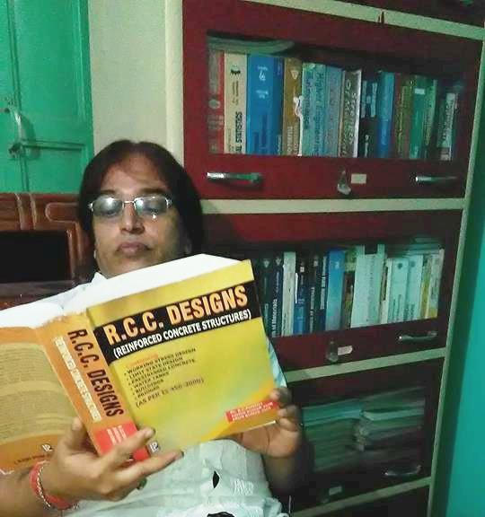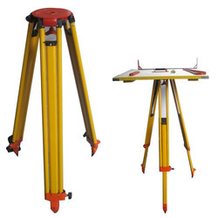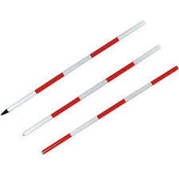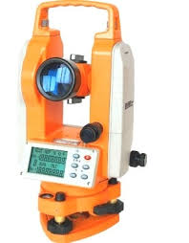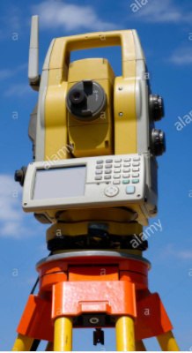

15. Brief description for expenses:
- Salary for work force – 18 lacs
- Expenses for equipment – 7 lacs
- Miscellaneous – 10 lacs
Total – INR 35, 00, 000 (aprox)

16. Brief Description for sales of consultancy support for:
- 1 BHK ( ticket – 22 lacs@ 12%) – 3 – INR 7,92,000
- 2 BHK (ticket – 45 lacs @10%) – 9 - INR 40,50,000
- 3 BHK (Ticket – 75 lacs @9%) - 3 – INR 20,25,000
Total – INR 68, 67, 000 (aprox)

Considering the above calculation we get the following P&L:
Sales – Expenses = Profit
INR 68, 67, 000 – INR 35, 00, 000 = INR 33, 67, 000.

17. Brief Description / layout of work area-
- Office layout – 700 sqft
- Design Room Layout – 16*16 sqft
- Meeting Room Layout – 16*16 sqft
- Library – 10*12 sqft
- Resources specifications – Table(2), chairs (4), books (180), drafting table, laptop(3), 3 D printing machine(1), drawing holder (1), printer/fax(1), AC(1), water dispenser(1),

18. Market Analysis – Market segment (99 acres, magic bricks, housing.com)

Industry Demographics:
- Builder companies -
- Construction consultancies -
- Construction agencies -

- Product line: No of rooms (Total/Super area, Built-up/Covered area, King size-area, Queen size-area, Kids Room – area, Store, No Bathroom (attached/separate), parking space(covered/uncovered- two wheeler or four wheeler), balcony, lift.
>1BHK: King size, Queen Size,1 Bedroom,1 Balcony, 2 toilets/washroom, kitchen, store (3D View )
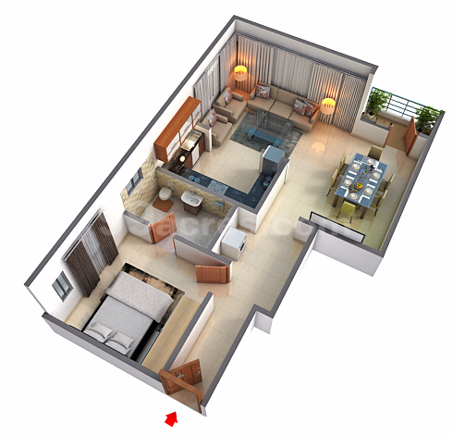
>2BHK: King size, Queen Size, Kid room, two toilets/washroom, kitchen, store@
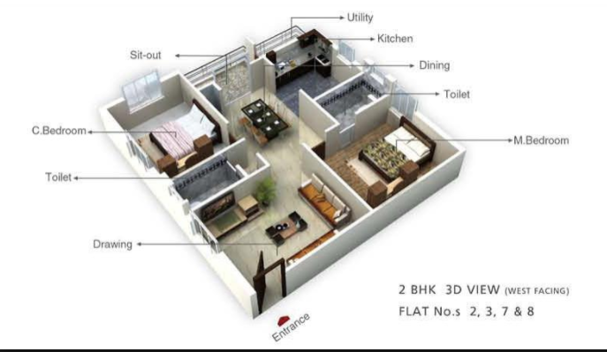

>3BHK: King size, Queen Size, Kid room, three toilets/washroom, kitchen, store @
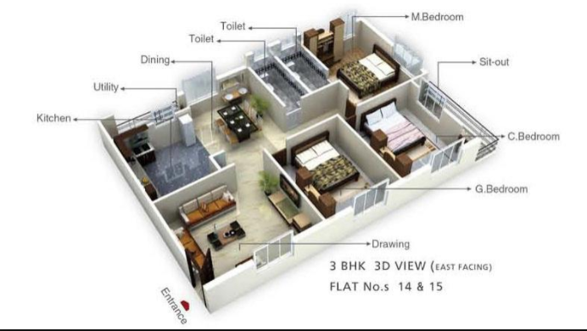

- Services
- Soil bearing capacity testing, load and stress testing along with FOS taken under consideration.
- Civil designing and development
- Project engineering
- Floor development
- Supervision and management of project
- Consultancy advisor (material to be used, project analysis)
- Project analysis:
- Aggregate Testing
1. Crushing value test
2. Drying shrinkage
3. Flakiness and Elongation Index
4. Impact value
5. Los angle abrasion test
6. Specific gravity and Water absorption
- Brick testing
1. Water Absorption test
2. Porosity and density
- Stone aggregate
- Fine aggregate
- Cement testing
1. Chemical Analysis Test
2. Compressive strength Test
3. Fineness Test
4. Heat of Hydration Test
5. Loss of Ignition Test
6. Setting Time Test
7. Soundness Test - Soundness define the ability of a hardness cement paste to retain its volume after setting. Lack of soundness is observed in the cement samples containing excessive amount of hard burnt-lime or magnesia. Test Method: IS: 4031(P-3)1990
- Steel testing
1. Elongation test.
2. Ultimate Tensile test
3. Proof stress/yield stress
- Water testing
- Cube testing
- Plate Load Test
- Concrete Testing
1. Design Mix testing- Design mix test helps in determining the suitable ingredients of concrete and determining their relative amounts with the objective of producing a concrete of the required ,strength, durability and workability as economically possible. It involves studying properties of aggregates, cement, water and admixture if any is used to determine the proper concrete mix. Test Method: IS: 10261
2. Chloride content test-determining calcium chloride & usability of concrete
3. Chloride pounding test-determine chloride ions ingress into concrete, Test Method-AASHTO T -277
4. Cube compressive strength-to assess concrete batch strength, Test Method- IS 456, IS-15658, IS- 516:1959
The cube test is the test most commonly used for determining concrete strength. The value of compressive strength can be used to assess the whether the batch that the concrete cube represents meets the required compressive strength. Test Method: IS: 456. IS: 15658- 2006, IS: 516-1959
5. Ultrasonic concrete testing –determination of uniformity of concrete, cavities, cracks & defects, Test-IS 13311
6. Depth of carbonation-CO2 reaction with cement makes carbonates affects Ph of concrete
7. Flexural Strength Test-determining bending strength, it is the ability of a beam/slab to resist in bending and is measured by loading un-reinforced 150mm*150mm concrete beam with a span 3 times the depth .The flexural strength is expressed as “Modulus of Rupture (MR).MR is about 12 to 20 percent of compressive strength,
Test Method: IS:516-1959, ASTMC 494-2010
8. Sulphate contents-Test Method-IS-812(P-118)
9. Water Absorption-Test –ASTM-1084
10. Pile Integrity Test (PIT)
11. Ad Mixture- --chloride free, high range water-reducing

SOIL INVESTIGATION FOR BUILDING CONSTRUCTION
Desktop study including previous uses
Visual inspection of the site
Assessing the site’s geology and hydrology
Carrying out sampling in accordance with methods agreed with the client
Laboratory analysis of the sample

Laboratory Test
1. Shear strength test-can be determined by Direct shear test method / Triaxial shear test method /Plain strain method
2. Compressibility test
3. Permeability test
4. Soil classification test
5. Vane shear test
6. Modified Procter compaction test
7. Particle size distribution by sieve Analysis test
8. Dynamic core Penetration test

Field Test
1. Plate Load test

Exhibit

- Geographical segment-
- Tier 1 – Noida @ 1BHK
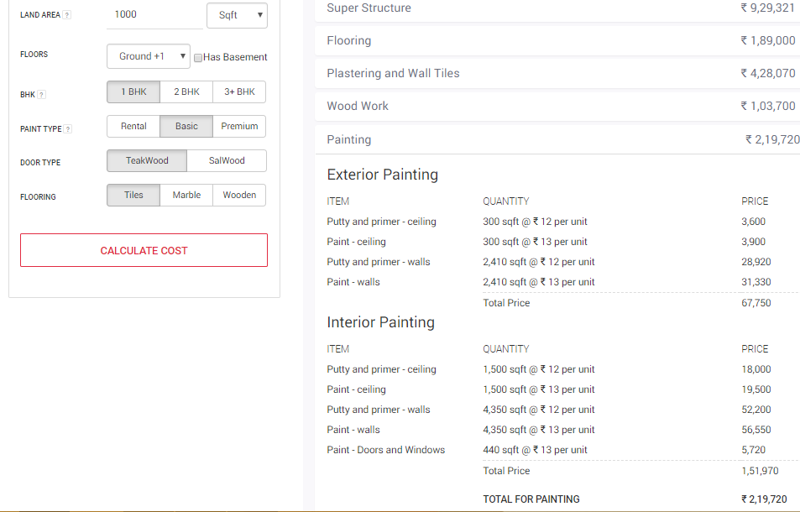

- Tier 1 – Noida @ 2BHK
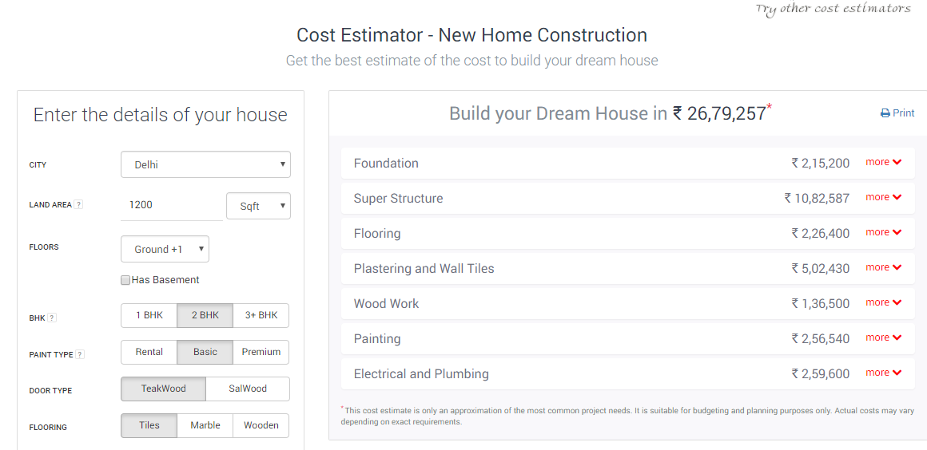

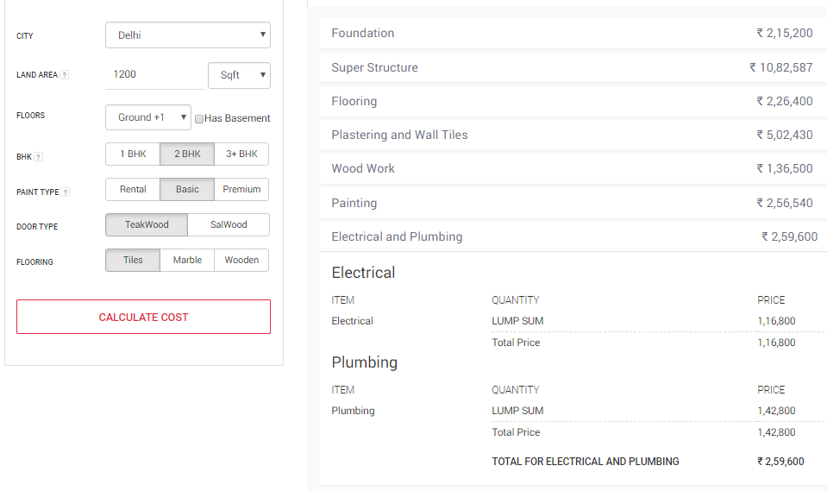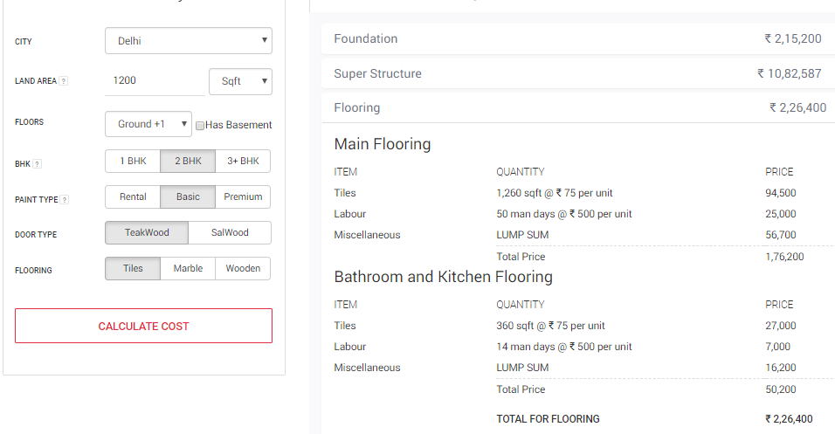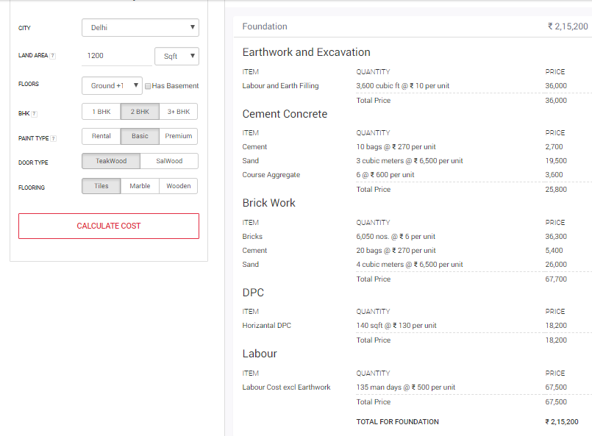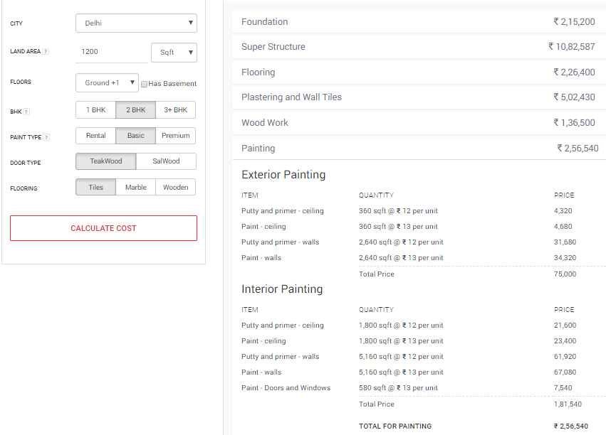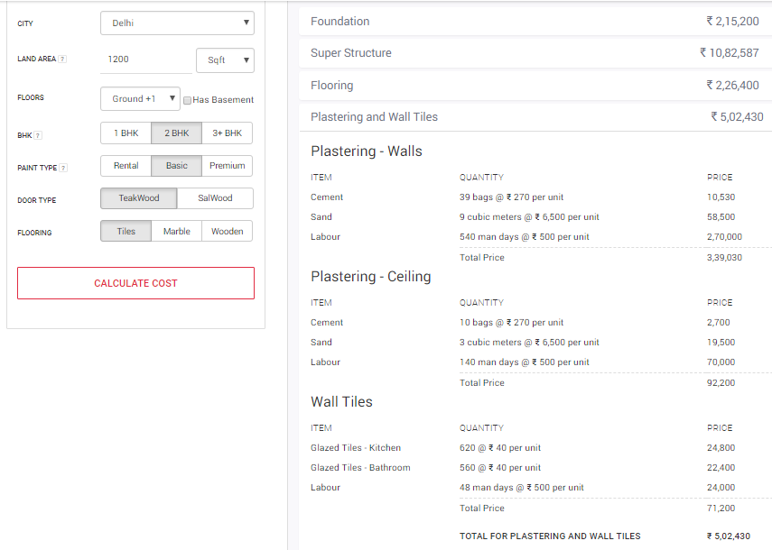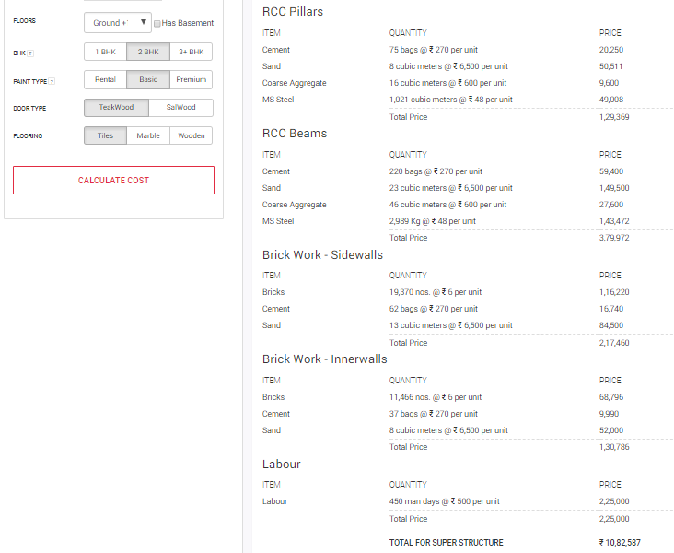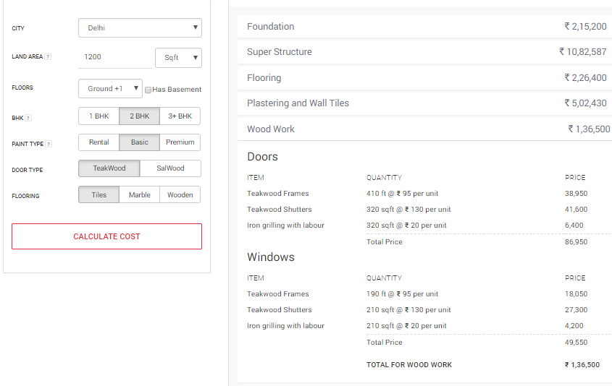

- Tier 1 City – Noida @ 3BHK
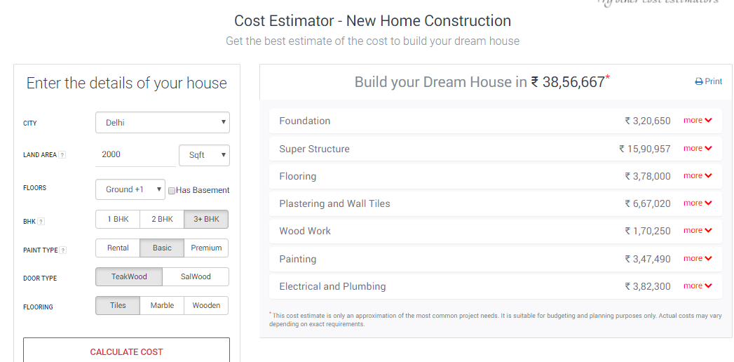

- Clients demand analysis: It’s a non–cyclic process, the demand rises and falls depending upon the market need which is depended on the international market.
- New jonnies (starting their career)-
- Newly-weds- couples
- Relocated families due to job change-
- Settling down after retirement

Marketing Strategy – 4P are Price, Positioning, Product/services, People
PRICE
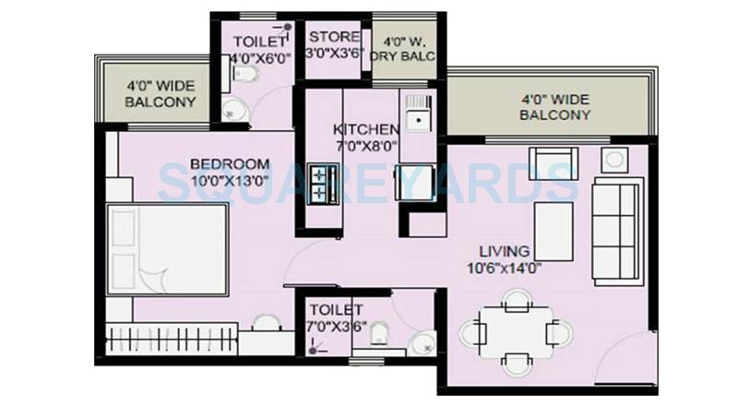

Exhibit 4: 1 BHK, 2 toilets
Super buildup area is 750 sqft. Estimate Final Price 22 Lac

Exhibit 5: 2 BHK, 2 toilets.
Super buildup area is 990 sqft. Estimate Final 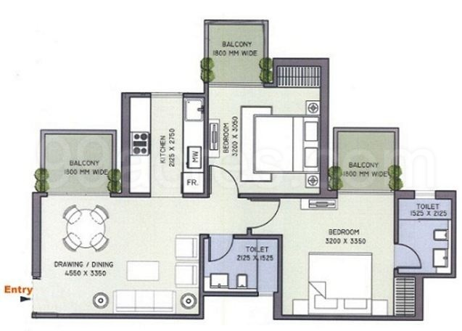Price 45 Lac

Exhibit 6: 3 BHK, 3 toilets
Super buildup area is 1720 sqft. Estimate Final Price 75 Lac
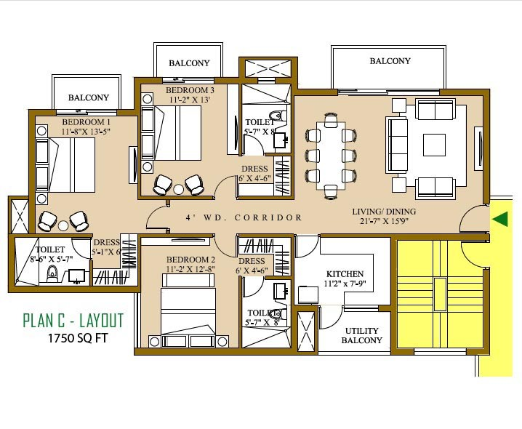

PRODUCT AND SERVICES
- Soil bearing capacity testing, load and stress testing along with FOS taken under consideration.
- Civil designing and development
- Project engineering
- Floor development
- Supervision and management of project
- Consultancy advisor (material to be used, project analysis)
PEOPLE
- Builders-(commercial & residential)
Large Project- More than INR 100 Cr
Medium Project- Between INR 50 Cr- 100 Cr
Small Project – INR 50 Cr and below
- Construction Agencies-
Architect
NGO
- Government Builder
Gram panchayat
Indra Awash yojana
- Independent individuals
Income Base-Newly married couple of job oriented and job retiring person earning up to Rs 50,000/month.

POSITIONING:
Creativity of your life by K2 Engineering and Construction Pvt Ltd.

SAFETY
Company will be committed to conducting business in a manner that protects the health and safety of all employees, customer and person living in the community where it operates. To accomplish this, the company will ensure that it complies with current health administration & occupational health, safety laws, will maintain its operation, procedures, technologies and policies accordingly.
Each employee will have the responsibility to fully comply with established safety norms and to perform work in such a manner as to prevent injuries to themselves and others. Company will focus more around job-site safety and plans to set up a comprehensive safety program. The company will be providing the operational team with the following safety gadgets: @

MARKETING PLAN
1. Digital Marketing- Company will use digital marketing tools to market its services. Tools like internet and mobile phone will be used. A Face-book will be created and an email will be sent across for creating brand awareness. Advertisement on www.99acres.com, www.magicbrics.com and other website will be given.
2. Newspaper— Advertisement in business newspaper like Mint, Economic Times and some of local newspaper will be given for the promotion of company services.
3. Business Tie-up- Company will make tie-ups with builders and other real estate companies and will try to associate with their services in order to develop its own brand.
4. Hiring of Agents—Local agents will be hired on commission basis in order to penetrate and market the services in deep level.
5. Conferences and Events—company will take part in conferences and events organized by association of designer in India and in abroad to create reputation of the whole company.

FINANCIAL PLAN
The following sections are the financial projections for K2 Engineering & Construction Ltd for the next three years. These tables represent a conservative estimation of revenues, expenses, and growth plan.

Income & Expenses for K2 Engineering and Construction Pvt Ltd.
Statement for Profit and Loss for K2 Engineering and Construction Pvt Ltd.
Revenue from Operation
Income from Operations statement | 2018-19 | 2019-20 | 2020-21 | 2021-22 | 2022-23 | Total
1 BHK @ 22 lacs | 3 | 5 | 7 | 10 | 13 | 38
Consulatncy fee @ 12 | 7,92,000 | 13,20,000 | 18,48,000 | 26,40,000 | 34,32,000
2 BHK @ 45 lacs | 9 | 12 | 12 | 13 | 15 | 61
Consulatncy fee @ 10 | 40,50,000 | 54,00,000 | 54,00,000 | 58,50,000 | 67,50,000
3 BHK @ 75 Lacs | 3 | 4 | 6 | 8 | 10 | 31
Consulatncy fee @ 9 | 20,25,000 | 27,00,000 | 40,50,000 | 5400000 | 67,50,000
Total flats | 9+6 | 12+9 | 12+13 | 13+18 | 15+23 | 130
Total Annual Sales | 68,67,000 | 94,20,000 | 1,12,98,000 | 1,38,90,000 | 1,69,32,000 | 5,84,07,000
Expenditure from Operation
Expenses from Operation Statement | 2018-19 | 2019-20 | 2020-21 | 2021-22 | 2022-23
Cost of set up | 5,00,000 | 1,00,000 | 1,00,000 | 1,50,000 | 2,00,000
(Website, Regstration, New Office space)
Salary of work force | 18,00,000 | 21,00,000 | 24,00,000 | 35,000,00 | 40,000,00
Allowances | 5,00,000 | 5,00,000 | 5,00,000 | 7,000,00 | 7,000,00
Travel & Telephone | 1,50,000 | 3,00,000 | 3,00,000 | 5,000,00 | 7,000,00
Legal expenes | 1,00,000 | 1,50,000 | 1,50,000 | 2,000,00 | 3,000,00
Branding & Events | 5,00,000 | 7,00,000 | 7,00,000 | 10,000,00 | 10,000,00
(Trade fair, seminars, Ads)
Maintanece Expenses | 2,00,000 | 2,00,000 | 2,00,000 | 4,000,00 | 5,000,00
Total Annual Operations Expenses | 37,50,000 | 40,50,000 | 43,50,000 | 64,50,000 | 74,000,00

Income |  |  | 2018-19 | 2019-20 | 2020-21 | 2021-22 | 2022-23
 | Revenue from Operation | 1 | 68,67,000 | 94,20,000 | 1,12,98,000 | 1,38,90,000 | 1,69,32,000
 | Other Income(Teaching) | 2 | 1,00,000 | 1,00,000 | 1,00,000 | 1,000,00 | 1,000,00
 | Total Revenue |  | 69,67,000 | 95,20,000 | 1,13,98,000 | 1,39,90,000 | 1,70,32,000
Expenditure
 | Purchase of Equipment | 3 | 7,00,000 | 7,00,000 | 7,00,000 | 10,000,00 | 10,000,00
 | Maintance Charge | 4 | 2,00,000 | 2,00,000 | 2,00,000 | 2,000,00 | 2,000,00
 | Operation Expenses | 5 | 35,50,000 | 38,50,000 | 41,50,000 | 60,50,000 | 69,000,00
 | Depriciation @ 10 | 6 | 70,000 | 1,40,000 | 2,10,00,000 | 3,10,000 | 4,10,000
 | Other Expenses(CSR) | 7 | 1,00,000 | 1,00,000 | 1,00,000 | 1,000,00 | 1,000,00
 | Loan Amount | 8 | 10,00,000 | 1,00,000 | 0 | 0 | 0
 | Finance Cost | 9 | 1,00,000 | 10,000 | 0 | 0 | 0
 | Total Expenses |  | 57,20,000 | 51,000,00 | 52,70,000 | 76,60,000 | 86,10,000
PBT |  | 10 | 12,47,000 | 44,20,000 | 61,28,000 | 63,30,000 | 84,22,000
Tax – GST | @18 | 11 | 2,24,460 | 7,95,600 | 1103040 | 11,39,400 | 15,15,960
Profit |  |  |  | Break Even
 |  | 12 | 10,22,540 | 36,24,400 | 50,24,960 | 51,90,600 | 69,06,040

Year Estimation
 | -30% | 2018-19 |  | 30%
 | 4876900 | 69,67,000 |  | 9057100
 | 57,20,000 | 57,20,000 |  | 57,20,000
Negative | 8,43,100 | 12,47,000 |  | 33,37,100
 |  | 2019-20
 | 6664000 | 95,20,000 |  | 12376000
 | 5100000 | 5100000 |  | 5100000
Lowest | 15,64,000 | 44,20,000 |  | 72,76,000 |  | Highest
 |  | 2020-21
 | 7978600 | 11398000 |  | 14817400
 | 52,70,000 | 52,70,000 |  | 52,70,000
Lowest | 27,08,600 | 61,28,000 |  | 95,47,400 |  | Highest
 |  | 2021-22
 | 97,93,000 | 1,39,90,000 |  | 18187000
 | 76,60,000 | 76,60,000 |  | 7660000
Lowest | 21,33,000 | 63,30,000 |  | 1,18,57,000 |  | Highest
 |  | 2022-23
 | 11922400 | 17032000 |  | 22141600
 | 8610000 | 8610000 |  | 8610000
Lowest | 3312400 | 8422000 |  | 1,35,31,600 |  | Highest
Depreciation of Equip
Cost of Equipment |  |  | 700000 |  | 700000 |  | 700000 |  | 1000000 | 1000000 | Total Dep.
year 2018-19 |  |  | 70000 |  | 0 |  | 0 |  | 0 | 0 | 70000
year 2019-20 |  |  | 70000 |  | 70000 |  | 0 |  | 0 | 0 | 1,40,000
year 2020-21 |  |  | 70000 |  | 70000 |  | 70000 |  | 0 | 0 | 2,10,000
year 2021-22 |  |  | 70000 |  | 70000 |  | 70000 |  | 1,000,00 | 0 | 3,10,000
year 2022-23 |  |  | 70000 |  | 70000 |  | 70000 |  | 1,000,00 | 1,000,00 | 4,10,000
Total Dep |  |  |  |  |  |  |  |  |  |  | 11,40,000

ANALYSIS by SWOT
STRENGTH - Employment and training opportunities in the field of construction. Private sector housing boom and commercial building demands & construction of the multi building projects on the feasible locations in the country. Good structured national network facilitates the boom of construction industry. Low cost well- educated and skilled labor force is now widely available across the country. Sufficient availability of raw material, manpower and natural resources in the country is supportive for the better growth rate as compared to neighboring market indicates better future scope in terms of new requirements and job stability. Hence a positive indicator of nations growth & development. Increased FDI in construction sector shows the boosted confidence of investors in Indian Economy.
WEAKNESS-Distance between construction projects reduces business efficiency. Training itself has become a challenge in today’s competitive environment. Changing skills requirements and an ageing workforce may emphasize the skills gap. Improvement in long-term career prospects is highly required to encourage staff retention and new entrants. External allocation of large contract becomes difficult. Lack of clearly defined processes and procedures for construction and its management lead to higher risk and uncertainty. Huge amount of money needs to be invested in this industry
OPPORTUNITY-: Continuous private sector housing boom will create more construction opportunities. Public sector projects through Public Private Partnerships will bring further opportunities. Developing supply chain through involvement in large projects is likely to enhance the chances in construction. Renewable energy projects will offer opportunities to develop skills and capacity in new markets. More flexible training delivery techniques are now available. Financial supports like loan and insurance and growth in income of people is in support of construction industry
THREAT-: Long term market instability and uncertainty may damage the opportunities and prevent the expansion of training and development facilities. Current economic situation may have an adverse impact on construction industry. Political and security conditions in the region and Late legislative enforcement measures are always threats to any industry in India. Infrastructure safety is a challenging task in construction industry. Lack of political willingness and support for promoting new strategies. Natural abnormal casualties such as earth quake and floods are uncertain and can prevent the construction boom inefficient accessibility in planning and concerning the infrastructure. Competitors are emerging in the industry by leaps and bounds.

FUTURE PROSPECTS -
After targeting Noida, Patna, Beghusarai company will spread its wing (office) across many cities of India like UP,Delhi,Gurgaon, Bihar, West Bengal, Jharkhand, Chhattisgarh, Madhya Pradesh, Maharashtra, Haryana, Punjab, Karnataka, channai,Telangana etc.
FAQ’S

Why use a building designer?
We at K2 Engg & Construction Pvt Ltd, building designer are here to protect human life from sudden collapse of your house due to wind, earthquake, Lateral earth pressure, soil failure due to shear, pore pressure and due to design failure of structure. We licensed building designer offer you an end to end design experience that will deliver your architectural project to approval and construction tendering stage.K2 Engg Building Design pride ourselves on our focus on delivering a user-friendly residential design that is both aesthetically pleasing and practical. We have a passion for sustainability principles and universal access (inclusive) design principles that we can apply to help realize your long-term lifestyle or workplace needs

What’s the difference between a building designer and an architect?
The Building Designers Association of India suggests that “there is no difference in the work that can be done by a building designer as opposed to an architect.
There are some differences in education and regulation between the professions but these make little difference to their work output.”

Who is K2 Engg Building Design?
“Made to individual order; custom-made” Our vision for K2 Engg for Building Design is to partner closely with our clients so that they can achieve their goals.
K2 is committed to delivering high quality residential building design and drafting services. Based in Noida, we offer our services throughout UP & Bihar,.Channai,Delhi
We like to apply sustainability principles and empathy for universal access to each of our endeavors while ensuring affordability and livability.
As a small operation K2 Building Design works with a select network of like-minded professionals, ensuring that we can deliver larger projects and cope with high productivity periods without impacting on quality or timeliness.

What types of buildings does K2 Engg design?

K2 Engg Building Design complete residential building designs, prepare all of the necessary working drawings and documentation needed for approval and construction. Our future planning is to deal with all Types of projects that we can help with include:
- Individual homes
- Duplexes
- Multiple residential units
- Renovations and extensions
- Town houses
- Office buildings
- Industrial buildings
- Warehouses
- Medical centers
- Child care centers
- Factories / Plant layouts
- Retirement villages
- Shop and office fit-outs

How long does the building design process take?
Building Design estimate our project timelines on a case-by-case basis taking into account:
- Design complexity,
- Our current project workload,
- The extent and quality of the information you can provide us, and
- How long it takes for us to get all the information needed.
If you choose to engage K2 Engg Building Design, when you sign your Fee Proposal we can detail what you can expect to receive and at what time to expect them.
At K2 Engg Building Design we keep our clients informed throughout our projects. If, for whatever reason, we expect some delays we will advise them straight away.

What general drafting & other services would K2 Engg Building Design consider?
K2 Engg Building Design can offer drafting services including:
- General residential houses drafting
- Supporting documentation for building approval and construction
- Civil drafting
- 3D concepts for marketing
- Interactive 3D animations
- Project Management
- Contract Administration
- Specifications

